Shiftbase template
Time off request template

About this template
A key element in human resources management is the efficient handling of employee vacation requests. A clear and structured approach to submitting and processing these applications is essential to ensure smooth operations and ensure staff satisfaction. In this context, we will address the importance of a standardized time off request form, which simplifies the processes and avoids misunderstandings. We highlight how such templates support the planning, approval and documentation of vacation and offer practical examples that you can apply directly in your company.
A well-designed time off request form not only makes the administrative process easier, but also helps to increase transparency and fairness in the approval process. It is important that such templates capture all relevant information, including the period of desired leave, the purpose and any special requirements.
We know that managing vacation and time off requests can be a challenging task, which is why we provide you with templates and instructions that can serve as a guide. We are convinced that a structured and clearly communicated process for handling vacation requests helps increase efficiency and promotes a positive working atmosphere. This templates is therefore designed to help you simplify the approval process and ensure fair treatment of all employees.

Employee time off request form
Employee name: _______________________
Personnel ID number: ________________ Department: __________________

Time off details
from/on ___________ to ___________
Number of vacation days requested: ___________days
It is a matter of:
☐ Collective holiday leave ☐ Special leave due to ________________________
☐ Other_________________________________

The requested vacation
☐ Approved ☐ Rejected

___________________ _________________________
place, date Signature supervisor

Try Shiftbase 14 days for free
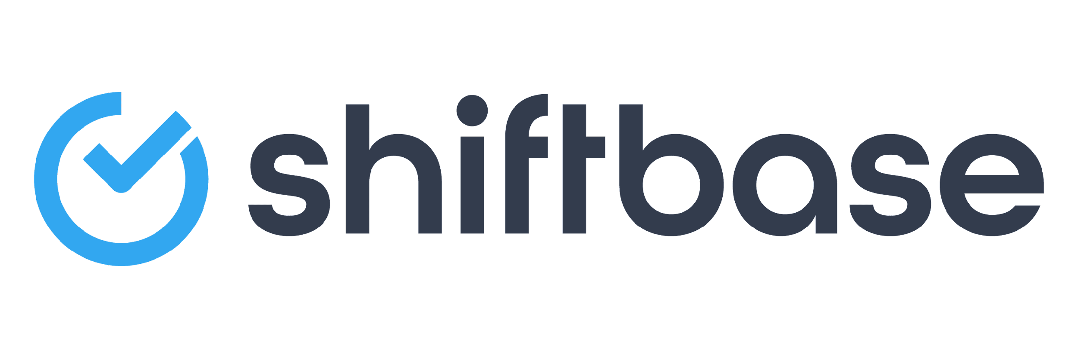
TRY SHIFTBASE FOR FREE AND WITHOUT OBLIGATION FOR 14 DAYS
Discover the comprehensive HR features of Shiftbase and see how you can manage all your employee data in one place. With Shiftbase, you can create detailed analyses of your business performance, gaining valuable insights into your company. Benefit from customizable reports and dashboards that provide you with a real-time overview of your entire company. Experience for yourself how Shiftbase simplifies your HR processes and optimizes your company management.
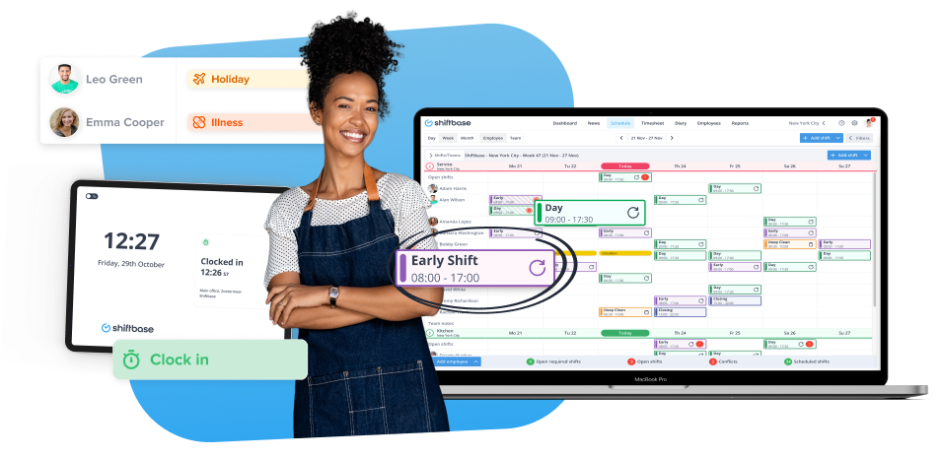
TRY IT NOW FOR FREE

