Shiftbase template  
Skills-Based Job description Template  
  


# About this template

Crafting job descriptions that emphasize skills rather than traditional qualifications is key to attracting a diverse and highly capable talent pool. This Skills-Based Job Description Template is designed to help you focus on practical competencies, measurable outcomes, and inclusive language, ensuring you find the best candidate for the job, regardless of their educational background.

**Position Title:**

(Insert job title here)

**Department/Team:**

(Insert department or team name here)

**Location:**

(Remote, Hybrid, or On-Site with city/state if applicable)

**Position Summary:**

Provide a brief overview of the role, focusing on the impact and key contributions of the position within the company.

**Example:** "We are seeking a results-driven [Position Title] to join our dynamic [Team/Department]. This role focuses on leveraging [specific skills or tools] to drive [specific outcomes or objectives]. If you excel in [key skills or traits], this role is for you."

**Key Responsibilities:**

(List the primary duties and outcomes expected for this role. Use action verbs.)

* [Responsibility 1: Focus on measurable outcomes and specific tasks.]
* [Responsibility 2: Include cross-functional collaboration if applicable.]
* [Responsibility 3: Emphasize growth opportunities or innovation.]

**Required Skills and Competencies:**

(Focus on practical, measurable skills rather than academic qualifications.)

* Proficiency in [specific tools, software, or methodologies].
* Strong ability to [specific skill, e.g., "analyze complex data sets" or "write engaging content"].
* Proven experience in [specific task or responsibility].
* Excellent [soft skill, e.g., communication, problem-solving, teamwork].

**Preferred Skills (Optional):**

(Highlight additional skills that would be beneficial but not mandatory.)

* Familiarity with [additional tools or methodologies].
* Experience in [specific industry or role].
* Certification in [relevant certifications].

**Key Performance Indicators (KPIs):**

(Provide measurable goals for success in this role.)

* Achieve [specific metric, e.g., "95% accuracy in data analysis"].
* Complete [task/outcome] within [timeframe].
* Maintain [standard, e.g., "positive client feedback score of 4.5+"].

**Benefits and Perks:**

(Briefly outline the unique benefits of working in this role or company.)

* Competitive salary and performance-based bonuses.
* Comprehensive health and wellness benefits.
* Opportunities for professional development and upskilling.

**Application Instructions:**

Provide clear instructions for applying to the position, including:

* Submit your application via [application portal or email address].
* Include your resume and a brief cover letter highlighting your relevant skills.
* Application deadline: [insert date].

**Equal Opportunity Statement:**

End with a statement reinforcing your commitment to diversity and inclusion.

**Example:** "[Company Name] is an equal opportunity employer. We celebrate diversity and are committed

# Try Shiftbase free for 14 days.



Explore Shiftbase's comprehensive HR features and learn how to manage all employee data in one place. With Shiftbase you can create detailed analyzes of your business performance and gain valuable insights into your business. Benefit from customizable reports and dashboards that give you a real-time overview of your entire business. Experience for yourself how Shiftbase simplifies your HR processes and optimizes your company management.

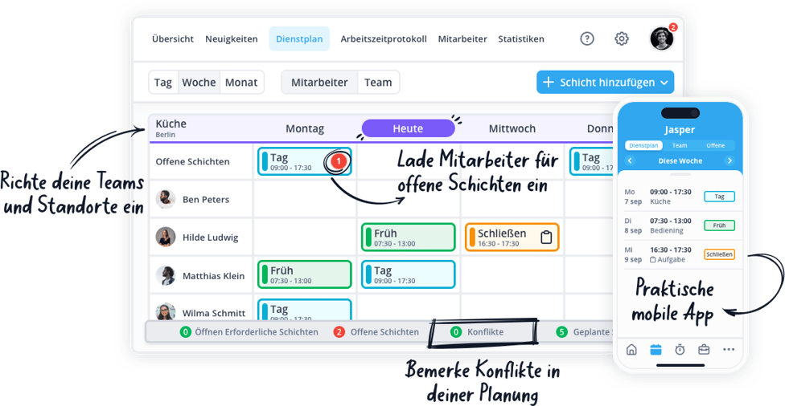

[TRY NOW FOR FREE](https://app.shiftbase.com/signup?plan=premium&language=de&signup_cta_source=hero-main&signup_cta_url=https:%2F%2Fwww.shiftbase.com%2Fde%2Flexikon)