Shiftbase Template
Recommendation letter

About this template
This template is designed to help employers and managers write strong, personalized recommendation letters for their employees. It provides a structured format for the letter and includes prompts for highlighting the employee's key skills, accomplishments, and contributions. The template is flexible and can be adapted to fit the specific needs of each employee and the position they are applying for.
How to Use the Template
- Gather information about the employee: Before you start writing, take some time to gather information about the employee. This includes their skills, experience, accomplishments, and contributions. You may want to review their resume, performance reviews, and any other relevant documents.
- Fill in the prompts: Use the prompts in the template to write about the employee's skills, accomplishments, and contributions. Be as specific and detailed as possible.
- Add your personal touch: Share anecdotes and personal observations about the employee. This will help to make the letter more engaging and persuasive.
- Proofread the letter carefully: Once you have finished writing the letter, proofread it carefully for any errors.

Recommendation letter template
To whom it may concern,
I am writing to highly recommend [Name of the Applicant] for the [specific position, role, or opportunity] position that they are applying for. I had the pleasure of working with [Name of the Applicant] at [Name of the Company or Organization] as [Your Position] from [Start Date] to [End Date].
During our time together, [Name of the Applicant] demonstrated exceptional skills and competencies in [relevant areas, such as project management, customer service, etc.]. They were particularly noted for their [specific positive qualities, such as creativity, teamwork, or dedication]. [Name of the Applicant] made significant contributions to the success of [specific projects or tasks]. Their ability to [specific skills or achievements, such as solve complex problems or develop effective strategies] greatly enriched our work.
In addition to their technical qualifications, I was particularly impressed by [specific personal qualities, such as interpersonal skills or reliability]. [Name of the Applicant] is a person with a strong work ethic and a strong sense of responsibility, making them a valuable asset to any team.
Based on my experience and working relationship with [Name of the Applicant], I can unreservedly recommend them for the [specific position, role, or opportunity] position. I am confident that [Name of the Applicant] would be a valuable asset to your organization and would be successful in achieving your goals.
I am happy to provide additional information or answer any specific questions you may have. You can reach me at [Your Contact Information, including phone number and email address].
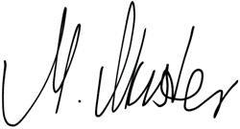
Sincerely,

[Your Signature] | [Your Position]

Try Shiftbase 14 days for free
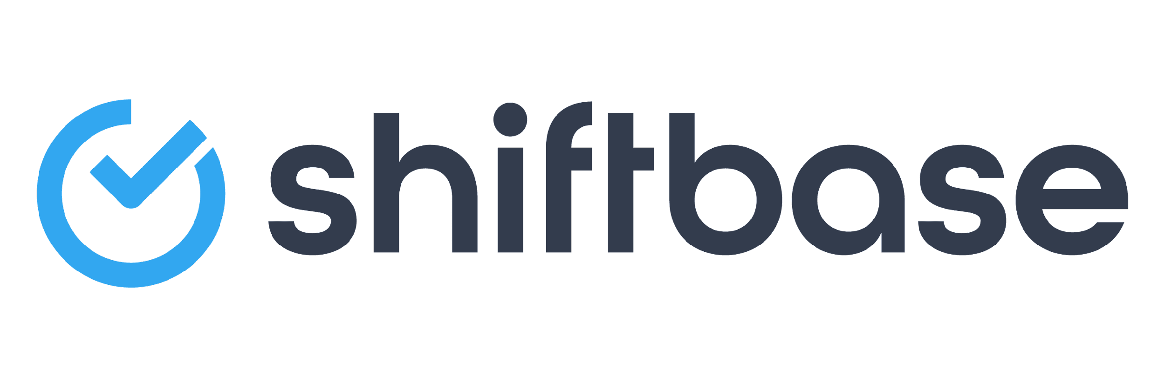
TRY SHIFTBASE FOR FREE AND WITHOUT OBLIGATION FOR 14 DAYS
Discover the comprehensive HR features of Shiftbase and see how you can manage all your employee data in one place. With Shiftbase, you can create detailed analyses of your business performance, gaining valuable insights into your company. Benefit from customizable reports and dashboards that provide you with a real-time overview of your entire company. Experience for yourself how Shiftbase simplifies your HR processes and optimizes your company management.
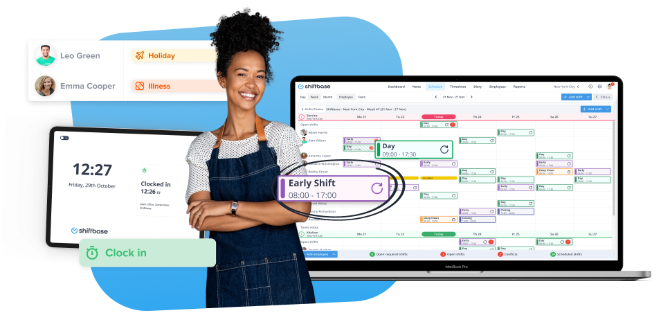

TRY IT NOW FOR FREE

