Shiftbase Template  
Panama Shift Compliance checklist

short line

# 

# 

# About this template

Use this checklist to make sure your Panama shift pattern meets legal and operational requirements under UK law. You can print it, check items off digitally, or turn it into an internal SOP.

## **📋 1. Employee consultation**

☐ I’ve informed employees about the shift pattern change

☐ Staff understand how the Panama schedule works

☐ Feedback was collected before implementation

☐ Union reps or employee reps were consulted (if applicable)

☐ Employees received a written copy of the new schedule

## **📄 2. Contract and documentation**

☐ Employment contracts include a clause about shift work

☐ Hours, breaks, and rest periods are clearly defined

☐ Opt-out agreements for the 48-hour rule are signed and stored

☐ Staff were informed about their right to opt in or out voluntarily

☐ Policies (e.g. absence, leave, sickness) have been updated to match the new schedule

## **⏱️ 3. Working hours and rest compliance**

☐ Average working hours do not exceed 48 per week (unless opted out)

☐ Employees receive at least 11 hours rest between shifts

☐ Employees receive at least 24 hours off every 7 days (or 48 in 14 days)

☐ A 20-minute break is scheduled during shifts longer than 6 hours

☐ Night shift workers do not exceed 8 hours per 24-hour period (if applicable)

## **🛡️ 4. Health and safety**

☐ Risk assessments for fatigue and long shifts have been completed

☐ Fatigue management policies are in place (e.g. task rotation, break enforcement)

☐ Night workers are offered free health assessments

☐ Employees know how to report health or wellbeing concerns

☐ Adjustments can be made for vulnerable or affected employees

## **📈 5. Record-keeping and audits**

☐ Working time records are kept for at least 2 years

☐ Opt-out forms are stored and accessible

☐ Time tracking is automated or reviewed weekly

☐ Any changes to the rota are documented and communicated

☐ We have a rota management system that ensures legal compliance

## **🧠 6. Ongoing check-ins**

☐ Managers regularly check in with shift workers

☐ Employee satisfaction and fatigue are reviewed at least quarterly

☐ The shift pattern is reviewed annually for fairness and efficiency

☐ New starters receive onboarding about shift expectations

☐ We have a feedback loop in place for rota improvements

# Try Shiftbase 14 days for free

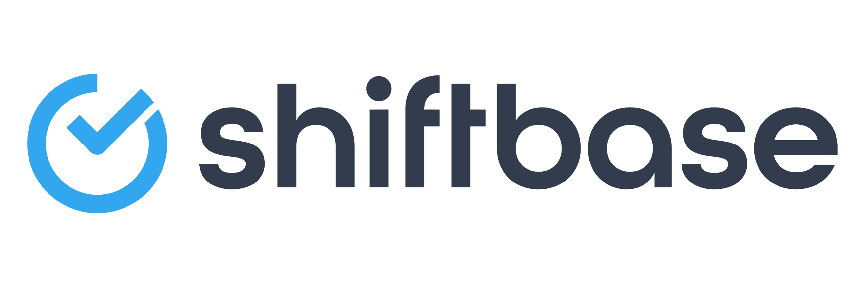

**TRY SHIFTBASE FOR FREE AND WITHOUT OBLIGATION FOR 14 DAYS**

Discover the comprehensive HR features of Shiftbase and see how you can manage all your employee data in one place. With Shiftbase, you can create detailed analyses of your business performance, gaining valuable insights into your company. Benefit from customizable reports and dashboards that provide you with a real-time overview of your entire company. Experience for yourself how Shiftbase simplifies your HR processes and optimizes your company management.

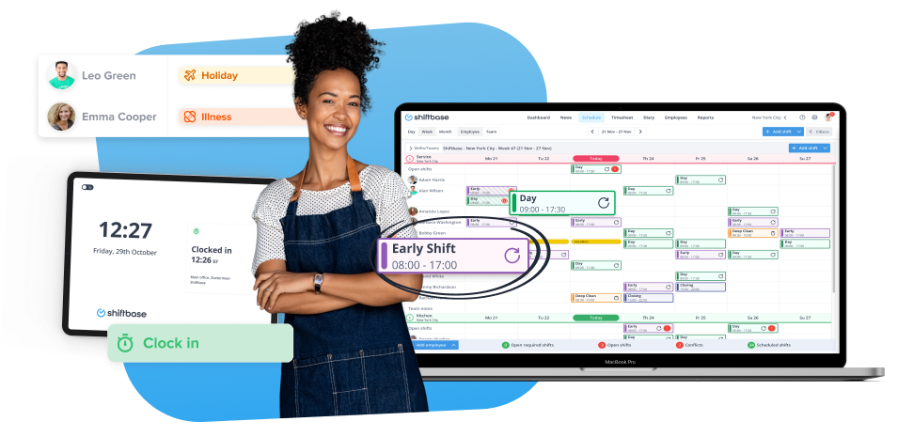

[TRY IT NOW FOR FREE](https://app.shiftbase.com/signup?plan=premium&language=en&signup_cta_source=hero-main&signup_cta_url=https:%2F%2Fwww.shiftbase.com)