Shiftbase Template
Organizational Charts
Template

About this template
An effective organizational chart is crucial for depicting the organizational structure and hierarchical relationships within a company. This template provides you with a structured basis for visualizing the company structure by highlighting important aspects such as department affiliation, areas of responsibility and direct reporting lines.

With predefined elements and design suggestions, this template helps you create an organizational chart that not only clearly depicts the internal structure, but also helps improve internal communication and process efficiency.

The goal of this template is to simplify the creation of an organizational chart that makes the complexity of organizational structures understandable and helps identify responsibilities and hierarchical relationships at a glance. It serves as a useful tool for personnel planning, training new employees and optimizing work processes in the company.

Hierarchical organizational chart

CEO
Administration
Marketing
Human Resource
Operations
Market Analysis
Advertising

Matrix organizational chart

CEO

Project Manager

Marketing Manager

Sales Manager

HR Manager

General
Manager
Product A
Employee
Employee
Employee
Employee
Employee
Employee
Product B

Flat organizational chart

CEO
Workforce
Workforce
Workforce
Workforce
Workforce

Functional organizational chart
CEO
Workforce
Production
Sales
West Region
East Region
Product A
Product B
Marketing
Distribution

Divisional organizational chart
CEO
Germany
USA
China
Distribution
Product
Finance

Network organizational chart
Online support
Recruitment
Payroll/ accounting

Call center

Graphic Design
Content Creation
(DE)
The Netherlands
External
Freelance

Distribution

Product Development
Production

Customer Success (APAC)
Asian Pacific
USA

CEO
(DE)

Customer Support
(DE)

Human Resources
(DE)

Marketing
(DE)

Project Management
(DE)

Distri-
bution
(DE)

Customer Support
(DE)

Try Shiftbase 14 days for free
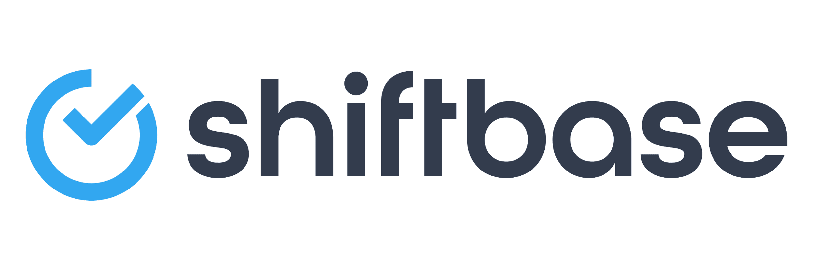
TRY SHIFTBASE FOR FREE AND WITHOUT OBLIGATION FOR 14 DAYS
Discover the comprehensive HR features of Shiftbase and see how you can manage all your employee data in one place. With Shiftbase, you can create detailed analyses of your business performance, gaining valuable insights into your company. Benefit from customizable reports and dashboards that provide you with a real-time overview of your entire company. Experience for yourself how Shiftbase simplifies your HR processes and optimizes your company management.
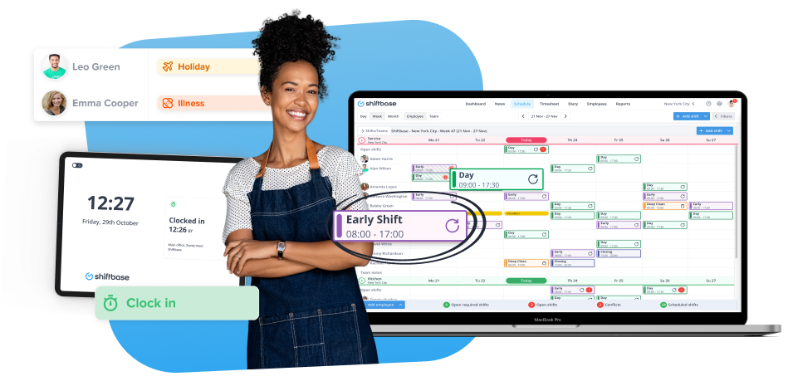

TRY IT NOW FOR FREE

