Shiftbase Template
Job postings examples

About this template
A key aspect of attracting the right talent for your business is crafting compelling job postings that effectively reach the right candidates and showcase the company's unique value proposition.
A well-structured job posting can make a significant difference in the number and quality of applications you receive. It can also help you attract candidates who are a good fit for the role and your company culture.
However, creating compelling job postings can be a challenge. It requires careful consideration of the target audience, the specific job requirements, and the company's branding and culture.
There are numerous ways to structure a job posting template, each with its unique emphasis and approach. Below you will find 3 variations of job posting templates to choose from according to the needs of your organization.

Job posting template #1
Company Name: [Insert company name]
Job Title: [Insert job title]
Position Type: [Full-time/Part-time/Contract/Temporary]
Location: [Insert location]
Pay Range: [Insert salary range or negotiable]
About Our Company:
[Provide a brief overview of the company, its mission, values, and what makes it a great place to work. Highlight the company's achievements, culture, and commitment to employee well-being.]
Job Overview:
[Present a clear and concise summary of the role, outlining the primary responsibilities, tasks, and outcomes expected of the incumbent.]
Essential Responsibilities:
[List the key duties and responsibilities of the position in a bulleted format, ensuring clarity and completeness.]
- [Task 1]
- [Task 2]
- [Task 3]
Qualifications and Requirements:
[Outline the minimum qualifications and requirements for the position, including educational background, experience, skills, and certifications.]
- [Requirement 1]
- [Requirement 2]
- [Requirement 3]
Preferred Skills and Experience:
[List any additional skills, experience, or qualifications that would be considered assets for the role.]
- [Skill 1]
- [Skill 2]
- [Skill 3]
Benefits and Perks:
[Highlight the attractive benefits and perks offered to employees, including salary, bonuses, health insurance, dental and vision coverage, retirement plans, flexible work arrangements, professional development opportunities, and company events.]
To Apply:
[Provide clear instructions on how to apply for the position, including the application link, email address, or contact information.]
Equal Opportunity Employer:
[State the company's commitment to equal employment opportunity and diversity, ensuring fair and unbiased hiring practices.]
Call to Action:
[Conclude the posting with a compelling call to action, encouraging interested candidates to apply and join the company's dynamic team.]
Contact Information:
[Provide the name and contact information of the recruiter or hiring manager responsible for reviewing applications.]

Job Posting Template #2
Headline: [Insert a compelling headline that captures the essence of the role and appeals to potential candidates.]
About the Role:
[Provide a concise overview of the position, highlighting the key responsibilities, opportunities for growth, and the impact the role will have on the organization.]
About You:
[Describe the ideal candidate, emphasizing the skills, experience, and personality traits that align with the role's requirements.]
What We Offer:
[Enumerate the attractive benefits and perks that the company provides, such as competitive salary, comprehensive health insurance, flexible work arrangements, professional development opportunities, and a vibrant company culture.]
Join Our Team:
[Utilize a compelling call to action to encourage interested candidates to apply and embark on a fulfilling career journey with the company.]

Job Posting Template #3
Headline: Embark on an Exciting Career Journey with [Company Name]
About Us: [Company Name] is a [Industry] leader, renowned for its [Company's unique qualities]. Our team is driven by innovation, collaboration, and a passion for creating [Products or services]. We offer a dynamic work environment where you can thrive, learn, and make a significant impact.
About the Role:
Join our team as a [Job Title] and play a pivotal role in [Position's contributions to the company]. As a [Job Title], you will be responsible for [Key responsibilities]. You will have the opportunity to [Career growth opportunities].
About You:
We are seeking an individual with [Essential qualifications] who possesses the following qualities:
- [Desired skills and experience]
- [Passion for [Industry or area of expertise]]
- [Ability to work collaboratively and independently]
- [Strong communication and problem-solving skills]
What We Offer:
In addition to a competitive salary and comprehensive benefits package, we offer:
- [Compelling company culture benefits]
- [Opportunities for professional development and training]
- [A supportive and collaborative work environment]
Join Our Team:
We are excited to consider talented individuals who share our passion for innovation and excellence. If you are ready to take your career to the next level, [Click here to apply] and join our dynamic team.
Image:
[Visual representation of the company's culture, values, or work environment to enhance the appeal of the job posting]

Try Shiftbase 14 days for free
TRY SHIFTBASE FOR FREE AND WITHOUT OBLIGATION FOR 14 DAYS
Discover the comprehensive HR features of Shiftbase and see how you can manage all your employee data in one place. With Shiftbase, you can create detailed analyses of your business performance, gaining valuable insights into your company. Benefit from customizable reports and dashboards that provide you with a real-time overview of your entire company. Experience for yourself how Shiftbase simplifies your HR processes and optimizes your company management.
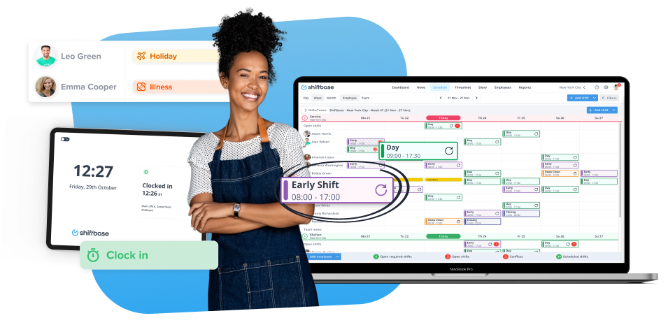

TRY IT NOW FOR FREE

