Shiftbase template
Job Description
Template

About this template

A clear and detailed job description is essential for successful recruitment. This template focuses on key elements such as job responsibilities, skills, and team collaboration to help you create effective descriptions.
With example texts and formulation aids, the template is intended to help you create a job description that not only precisely defines the role, but also presents your company as an attractive employer.
The goal is to ensure accurate communication about job requirements while projecting a positive company image. This template serves as a practical aid for creating clear and attractive job descriptions.

Job description sample
Example of a marketing professional

Company overview
[Company Name] is a leading company in the[industry], known for[Brief description of the company and its main products/services].

Title of the position
Sales marketing manager

Department
Marketing department

Supervisor and deputy
- Superior:[Name of Marketing Managers]
- Substitute: [Name of deputy person or position]

Location
[Office location or reference to remote work]

Objectives of the position
- Increasing brand awareness and positioning the company in the market.
- Effective implementation of marketing strategies to achieve sales goals.
- Promoting customer retention and acquisition through innovative marketing campaigns.

Area of ​​responsibility
- Development and implementation of marketing strategies and campaigns.
- Analyzing market trends and audience data to support the development of marketing strategies.
- Collaborate with other departments (such as sales and product development) to coordinate marketing efforts.
- Create and manage content for various marketing channels, including social media, email marketing and the company website.
- Monitoring and analyzing the performance of marketing campaigns and creating reports.
- Management and maintenance of relationships with external partners and suppliers.

Cooperation
The marketing sales manager works closely with colleagues in the department to jointly overcome marketing challenges. Regular communication with his manager, including providing detailed reports on marketing campaigns, is a central aspect of his work. This collaboration contributes significantly to effectively achieving the company's marketing goals

Requirements
TheThe incumbent has extensive knowledge of marketing and is experienced in dealing with current marketing tools and strategies. He leads marketing campaigns from planning to execution, combining creativity with analytical thinking. Thanks to his expertise in data analysis, he makes well-founded marketing decisions and continuously optimizes marketing strategies.

Try Shiftbase free for 14 days.
TRY SHIFTBASE FOR FREE AND WITHOUT OBLIGATION FOR 14 DAYS
Discover the comprehensive HR features of Shiftbase and see how you can manage all your employee data in one place. With Shiftbase, you can create detailed analyses of your business performance, gaining valuable insights into your company. Benefit from customizable reports and dashboards that provide you with a real-time overview of your entire company. Experience for yourself how Shiftbase simplifies your HR processes and optimizes your company management.
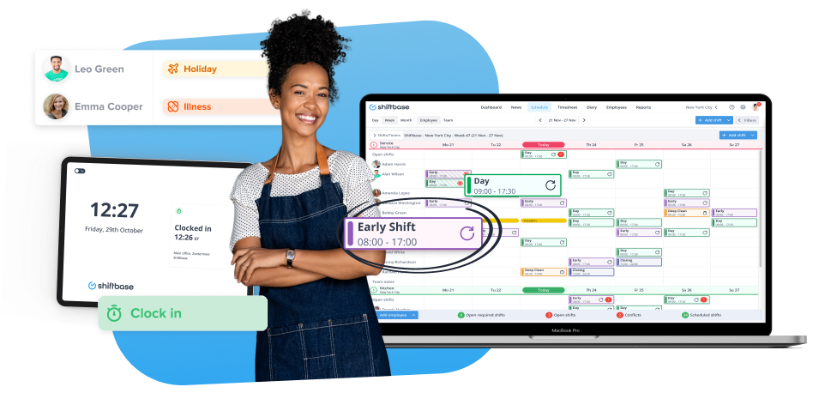

TRY IT NOW FOR FREE

