Shiftbase template  
Employee Tardiness Warning  


# 

# 

# 

# 

# 

# 

# 

# About this template

Punctuality is essential in maintaining a productive and efficient workplace. Excessive tardiness can disrupt workflows, reduce team morale, and impact overall business operations. When an employee consistently arrives late, it is important to address the issue professionally and in a structured manner.

This Excessive Tardiness Warning Letter Template is designed to help employers and managers formally communicate concerns regarding an employee's repeated lateness. It serves as an official record of the issue, outlines expectations for improvement, and informs the employee of potential consequences if tardiness continues.

# 

# Employee Tardiness Written Warning

**[Your Company Name]**

**Company Address**

**Date: [Insert Date]**

Employee Name: [Employee's Full Name]

Position: [Employee’s Job Title]

Department: [Department Name]

**Subject: Written Warning for Excessive Tardiness**

Dear [Employee's Name],

We are issuing this formal written warning due to your repeated instances of tardiness, which have been affecting your work performance and our team’s productivity.

| **Details of tardiness instances:** | |
| --- | --- |
| **Date:** | **Minutes late:** |
|  |  |
|  |  |
|  |  |
|  |  |

**Impact of Tardiness:**

Your continued late arrivals have caused:

· Disruptions in workflow.

· Increased workload for colleagues.

· Missed deadlines or delays in projects.

**Required Improvement:**

To remain compliant with our attendance policy, you are expected to:

· Arrive on time for all scheduled shifts starting immediately.

· Notify your supervisor in advance if a delay is unavoidable.

**Next Steps and Consequences:**

If this pattern of tardiness continues, further disciplinary actions may be taken, up to and including termination as per company policy.

Acknowledgment:

Please sign below to acknowledge that you have received and understood this warning. Signing does not necessarily mean you agree but confirms that you have read and received this document.

**Employee Signature:** _______________________

**Date:**_______________________

**Manager Signature**: _______________________

**Date:** _______________________

# Try Shiftbase 14 days for free

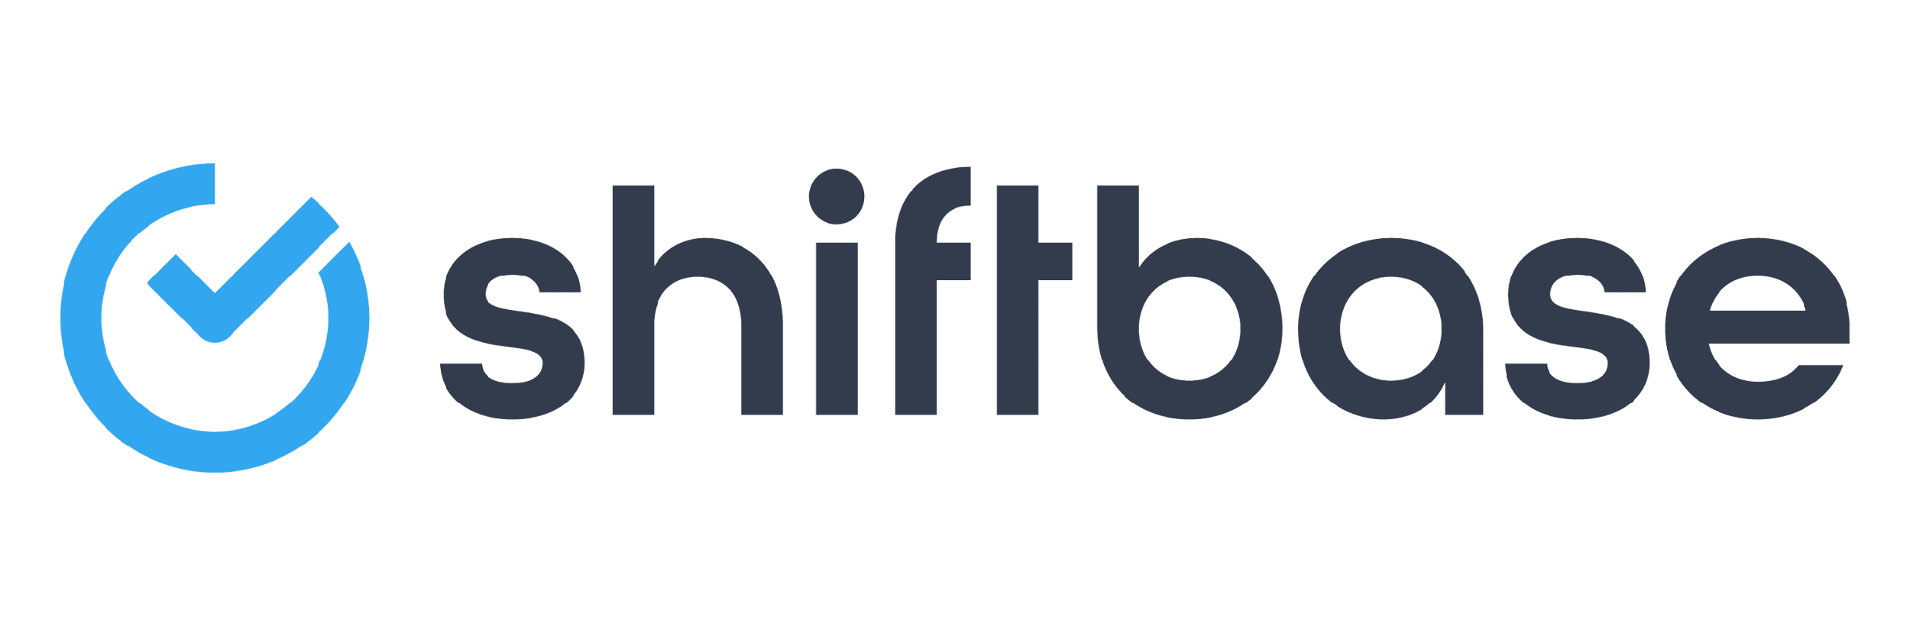

**TRY SHIFTBASE FOR FREE AND WITHOUT OBLIGATION FOR 14 DAYS**

Discover the comprehensive HR features of Shiftbase and see how you can manage all your employee data in one place. With Shiftbase, you can create detailed analyses of your business performance, gaining valuable insights into your company. Benefit from customizable reports and dashboards that provide you with a real-time overview of your entire company. Experience for yourself how Shiftbase simplifies your HR processes and optimizes your company management.

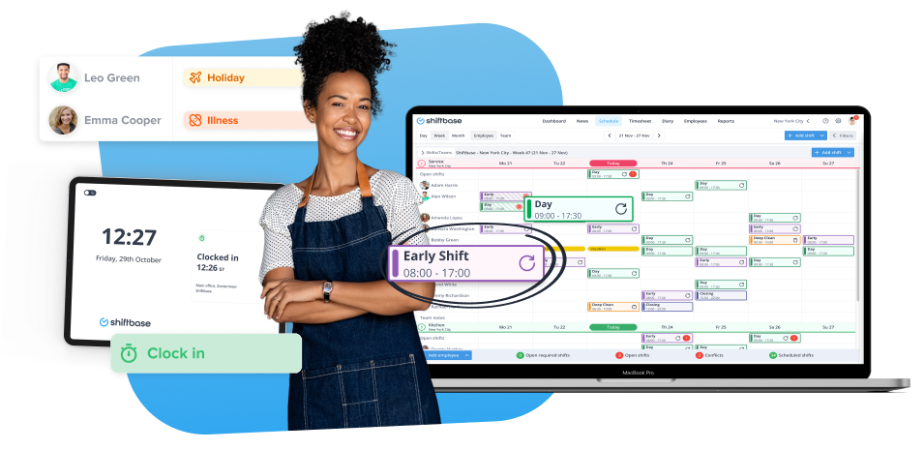

[TRY IT NOW FOR FREE](https://app.shiftbase.com/signup?plan=premium&language=en&signup_cta_source=hero-main&signup_cta_url=https:%2F%2Fwww.shiftbase.com)