Shiftbase Template
Employment Reference Letter

About This Template
This template is designed for use by HR managers, employers, or supervisors who wish to provide a reference for a former or current employee. It is structured to offer a comprehensive and professional endorsement of the individual's skills, work ethic, and contributions during their employment.
Key Features of the Template:
- Formal and Professional Tone: The language used is formal, suitable for an official employment reference letter, instilling a sense of professionalism and respect.
- Customizable Sections: The template includes placeholders like [Employee's Name], [Company Name], and [Employee's Position], which can be easily replaced with specific details relevant to the individual being referred.
- Highlighted Skills and Achievements: There is space to mention the employee’s specific tasks, projects, skills, and character traits, allowing for a personalized and detailed reference.
Customization Tips:
- Be specific about the employee’s contributions and skills.
- Use examples or brief anecdotes if possible to illustrate their abilities.
- Ensure that the information is accurate and reflects the employee’s role and responsibilities.
- Update the contact information section with your current phone number and email address.
This template serves as a general guideline and should be tailored to reflect the individual circumstances of the employee and the nature of their work with the company.

[Sender's Name] ,[Position]
[Company] ,[Company Address]
[City, Postal Code]
[Telephone Number],[Email Address]

Employment Reference Letter for [Employee's Name]
Dear Sir/Madam,
It is with great pleasure that I write this letter of reference for [Employee's Name], who has been employed at our company, [Company Name], as [Employee's Position]. During his/her time with us, [Employee's Name] has demonstrated exceptional skills and remarkable professionalism.
[Employee's Name] exhibited great competence in [specific tasks or projects] and showed an excellent work ethic. His/Her positive attitude and ability to work in a team have significantly contributed to the success of our team.
Particularly noteworthy are his/her [special skills or characteristics, e.g., leadership abilities, team spirit, expertise]. [Employee's Name] has always displayed high motivation and a strong commitment to his/her tasks.
I am convinced that [Employee's Name] will be a valuable addition to any organization. I recommend [Employee's Name] without any reservations and look forward to seeing his/her further successes.
For any further information, I am at your disposal. You can reach me at [Telephone Number] or via email at [Email Address].
Sincerely,
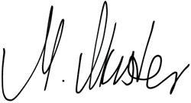

[Sample Signature of the Sender | Position in the Company]

Try Shiftbase 14 days for free
TRY SHIFTBASE FOR FREE AND WITHOUT OBLIGATION FOR 14 DAYS
Discover the comprehensive HR features of Shiftbase and see how you can manage all your employee data in one place. With Shiftbase, you can create detailed analyses of your business performance, gaining valuable insights into your company. Benefit from customizable reports and dashboards that provide you with a real-time overview of your entire company. Experience for yourself how Shiftbase simplifies your HR processes and optimizes your company management.
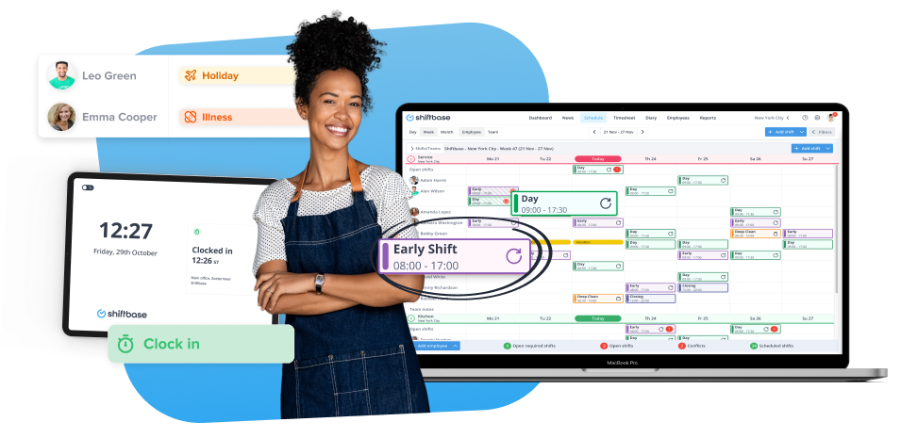

TRY IT NOW FOR FREE

