Shiftbase Template
Employer reference letter

About this template
Employer reference letters are crucial components of a job application, providing valuable insights into an applicant's professional background and qualifications. This free template aims to simplify the process of crafting comprehensive and impactful reference letters for former employees.
Purpose
This template serves as a guide to help employers provide tailored and informative feedback about their former employees. It incorporates essential elements to ensure the reference letter effectively showcases the applicant's strengths, accomplishments, and overall suitability for the desired position.
Key Features
- Structured Format: The template follows a clear and organized layout, making it easier to present the information in a concise and professional manner.
- Tailored to Different Positions: Adaptable to accommodate various job titles and industries, ensuring the reference is relevant to the applicant's career aspirations.
- Confidentiality Emphasis: Emphasizes the importance of maintaining confidentiality and respecting the applicant's privacy.

[Name of the Company]
Company Logo
[Address of the Company]
[Postal Code, City]
[Place, Date]

Employer Reference Certification
Mrs./Mr. [Name of the Employee], born on [Date of Birth], was employed at [Name of the Company] as a [Job Title] in the [Department] from [Start Date of Employment] to [End Date of Employment].
We are a medium-sized company in the [Industry] and [brief introduction of the company here]. We currently employ around [Number of Employees]. Our company headquarters are located in [Location of Company Headquarters].
Mrs./Mr. [Name of the Employee] was involved in the following areas:
- [List of Duties and Areas of Responsibility]
- [List of Duties and Areas of Responsibility]
He/She distinguished himself/herself with [Description of Competencies and Qualifications, e.g., Expert Knowledge, Independence, Teamwork].
We have known Mrs./Mr. [Name of the Employee] as a [Description of Work Behavior and Performance, e.g., committed, reliable employee]. His/Her performances have always fully met our expectations.
Mrs./Mr. [Name of the Employee] is leaving our company of his/her own accord. We thank him/her for the work performed and wish him/her all the best for his/her professional and private future.
With kind regards,
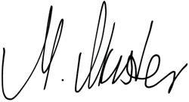
[Sample Employer's Signature | Position in the Company]
Your Company | Street | Postal Code, City | Homepage | Phone Number | Fax | Email | VAT ID

Try Shiftbase 14 days for free
TRY SHIFTBASE FOR FREE AND WITHOUT OBLIGATION FOR 14 DAYS
Discover the comprehensive HR features of Shiftbase and see how you can manage all your employee data in one place. With Shiftbase, you can create detailed analyses of your business performance, gaining valuable insights into your company. Benefit from customizable reports and dashboards that provide you with a real-time overview of your entire company. Experience for yourself how Shiftbase simplifies your HR processes and optimizes your company management.
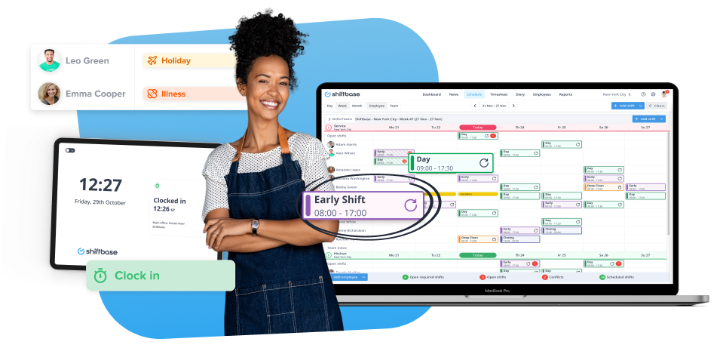

TRY IT NOW FOR FREE

