Shiftbase template  
Employee onboarding checklists

# 

# 

# 

# **About this template**

# This checklist and template for onboarding and training new employees serves as a guide. It is important to note that an induction plan is not universally suitable for all industries, work positions and target groups. Rather, the individual characteristics of each specific situation should always be taken into account.

Make the start of your new employees successful – read our [comprehensive guide on employee onboarding](https://www.shiftbase.com/glossary/onboarding) for everything you need to know.

# **Training Checklist**

|  |  |
| --- | --- |
| **Preparation** | **Check** |
| Has a specific concept been developed for the training of the new employee? |  |
| Has the team received information about the new colleague? |  |
| Are all required personnel documents present and complete? |  |
| Was a welcome letter with all necessary details (meeting point, time, arrival and parking instructions, possible dress code) sent before the first day of work? |  |
| Who is responsible for welcoming the new employee? |  |

|  |  |
| --- | --- |
| **Setup of the workplace** | **Completed** |
| Are all necessary work equipment and resources (such as technical equipment and office supplies) available and ready for use? |  |
| Is there a work cell phone available with a connection assigned to the new employee? |  |
| Is the work computer functional and fully equipped with the required software? |  |
| Have access to all necessary systems, including the necessary authorizations and passwords, been set up? |  |
| Is the new employee's email account functional? |  |
| Has the new employee been added to the email and postal distribution lists? |  |
| Has the new employee's name been updated on their office door and in internal company directories? |  |
| Is the onboarding program prepared and ready to be handed over to the new employee? |  |
| Is there a written company guide with all the essential information for new employees, including contact details of important contacts? |  |
| Has a small welcome gift been prepared for the new employee? |  |

|  |  |
| --- | --- |
| **Employee Onboarding** | **Completed** |
| Was the new employee given an introduction to the company, including information about products, customers and locations? |  |
| Have the basic principles of the company culture been explained to the new employee? |  |
| Did the new employee get to know all the key areas and contact points in the company during a tour? |  |
| Has the employe been introduced to the members of his team? |  |
| Did the new employee have the opportunity to have a personal conversation with their manager? |  |
| Does the employee know how to access office supplies? |  |
| Have they been given all the necessary keys or access cards? |  |
| Has the new employee received his company ID card and name tag? |  |
| Was the employee provided with necessary work clothing or protective equipment? |  |
| Have safety regulations and other operating rules been taught to the new employee? |  |
| Were they informed about the regulations regarding working hours, breaks and the recording of working hours? |  |
| Has the employee been informed about the company's vacation regulations? |  |
| Is the employee aware of how sick leave is handled in the company? |  |
| Has the new employee signed all necessary agreements, such as a confidentiality agreement or data protection agreements? |  |

|  |  |
| --- | --- |
| **Training in the work area** | **Completed** |
| Was the distribution of tasks within the team and the entire company made clear to the new employee? |  |
| Have the specific tasks, responsibilities and authorities of the new position been clearly communicated? |  |
| Have the necessary instructions taken place, for example in relation to the operation of office technology or machines? |  |
| Did the new employee carry out the activities planned for induction according to the planned concept? |  |
| Did all onboarding training prepared for the employee take place? |  |
| Were the planned feedback discussions carried out on time and as planned? |  |

# **Training Template**

Name of new employee: _______________________________

Department: ____________________________________________

Superior: _________________________________________

Start date new employee: _____________________________________

# 

**Phase 1: Before starting work**

|  |  |  |
| --- | --- | --- |
| **Task** | **Responsible Person** | **Date of Completion** |
| Notify HR and specialist departments |  |  |
| Outline the responsibilities of the position |  |  |
| Check personnel files: Are there any documents still outstanding? |  |  |
| Inform colleagues about the new addition to the team |  |  |
| Appoint an expert supervisor from the team |  |  |
| Send information email to the new employee:   * Start date and time * Meeting point and reception committee * Parking options and connections to public transport * Necessary items to bring |  |  |
| Prepare the workplace:   * Select place * Organize table, chair and tools * Provide PC, keyboard and mouse * Configure your PC, install programs and purchase licenses * Prepare access data |  |  |
| Provide key |  |  |
| Organize receipt documents:   * Guidelines and house rules * organization chart * Contact persons and telephone list * Regulations for recording working hours and breaks * Non-disclosure agreement |  |  |
| Add to mailing and email distribution lists |  |  |
| Enter appointments in the new employee's calendar |  |  |
| Organization of necessary training, e.g. in matters of safety |  |  |
| Plan tasks for the first few days |  |  |
| Create an induction plan for programs |  |  |
| Prepare a small welcome gift, such as a cup |  |  |

**Phase 2: On the first day**

|  |  |  |
| --- | --- | --- |
| **Task** | **Responsible Person** | **Date of Completion** |
| Final check to make sure all the necessary things are present |  |  |
| Welcoming the new employee |  |  |
| Hand over the receipt documents |  |  |
| Hand out the necessary materials:   * Keys * Equipment |  |  |
| Leadership through the company:   * Introduction to colleagues and departments * Tour of the premises (e.g. kitchen, canteen, etc.) |  |  |
| Explanation of the further induction process and expectations for the coming days |  |  |
| Take a break together with your colleagues |  |  |

**Phase 3: In the first week**

|  |  |  |
| --- | --- | --- |
| **Task** | **Responsible Person** | **Date of Completion** |
| Familiarization with all required programs and equipment: Set appointments and work through the docket step by step |  |  |
| Presentation of the entire product and service portfolio |  |  |
| Explanation of the company philosophy |  |  |
| Further detailed explanations of the activity to be carried out |  |  |
| Instructions on safety and security |  |  |
| Accompaniment and support in attending first appointments and meetings |  |  |
| Review of the first completed tasks |  |  |
| At the end of the week, collect feedback and determine whether there is a need for further development in certain areas |  |  |

**Phase 4: In the first month**

|  |  |  |
| --- | --- | --- |
| **Task** | **Responsible Person** | **Date of Completion** |
| Facilitate introductions to other departments and get to know all employees |  |  |
| Identify and work on any remaining open points |  |  |
| Determine the need for further training and select suitable seminars |  |  |
| Discuss the work results and identify possible improvements |  |  |
| Obtain regular feedback in order to continuously optimize the onboarding process |  |  |

# 

# Try Shiftbase 14 days for free



**TRY SHIFTBASE FOR FREE AND WITHOUT OBLIGATION FOR 14 DAYS**

Discover the comprehensive HR features of Shiftbase and see how you can manage all your employee data in one place. With Shiftbase, you can create detailed analyses of your business performance, gaining valuable insights into your company. Benefit from customizable reports and dashboards that provide you with a real-time overview of your entire company. Experience for yourself how Shiftbase simplifies your HR processes and optimizes your company management.

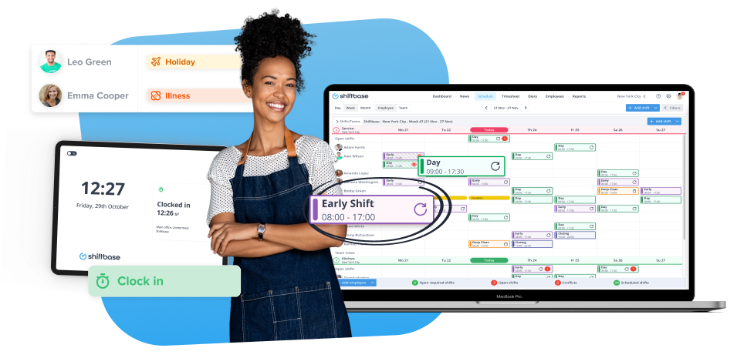

[TRY IT NOW FOR FREE](https://app.shiftbase.com/signup?plan=premium&language=en&signup_cta_source=hero-main&signup_cta_url=https:%2F%2Fwww.shiftbase.com)