Shiftbase template
Employee Meeting Template

About this template
One of the complex challenges in human resources management is the effective implementation and documentation of employee catch ups and appraisals. The correct approach to logging these conversations is crucial in order to make communication within the company transparent and comprehensible. This template covers various aspects of employee meetings, including the preparation, implementation and follow-up of such meetings.
A well-structured and professionally conducted employee meeting can not only help clarify expectations, but also make employees feel valued. It is important to use the right techniques to effectively give and receive feedback, set goals and promote employee development.
Clear and respectful communication during employee meetings is beneficial for everyone involved, and we hope this template will help you optimize your conversations and promote positive team relationships.
Employee meeting form |  |  |  |  | Confidential
Name |  |  |  |  | Employee ID
Function |  |  |  |  | Employed since
Employment Date |  |  |  |  | Superior
Place and date of the meeting
Reason for meeting |  |  |  |  |  | (eg. catch up, performance review)
Points of discussion during meeting
Point #1
Point #2
Point #3
New agreements/ SMART goals
Notes & comments
Next meeting date
___________________________ _______________________
Date, signature of manager Date, signature of employee

Try Shiftbase 14 days for free
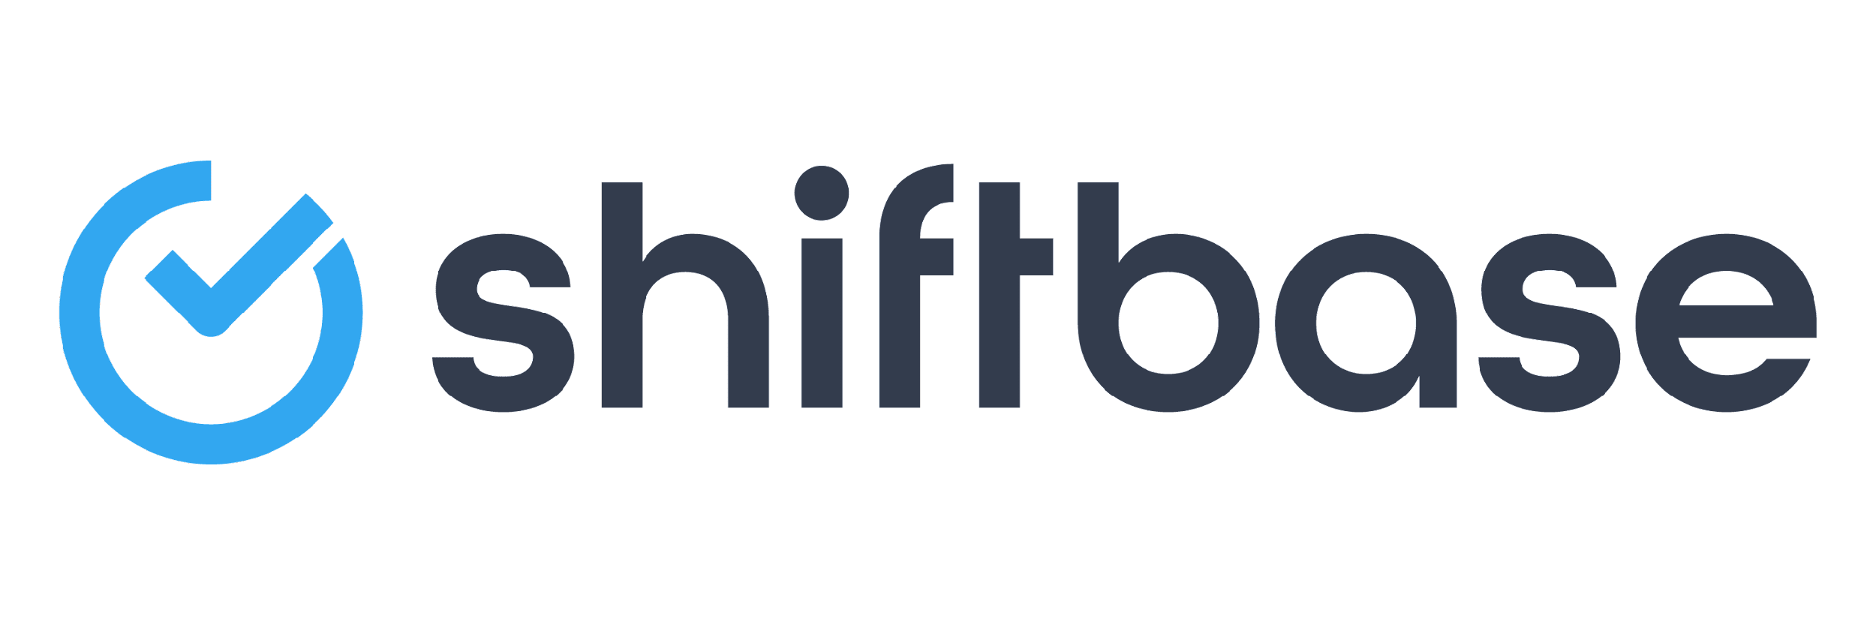
TRY SHIFTBASE FOR FREE AND WITHOUT OBLIGATION FOR 14 DAYS
Discover the comprehensive HR features of Shiftbase and see how you can manage all your employee data in one place. With Shiftbase, you can create detailed analyses of your business performance, gaining valuable insights into your company. Benefit from customizable reports and dashboards that provide you with a real-time overview of your entire company. Experience for yourself how Shiftbase simplifies your HR processes and optimizes your company management.
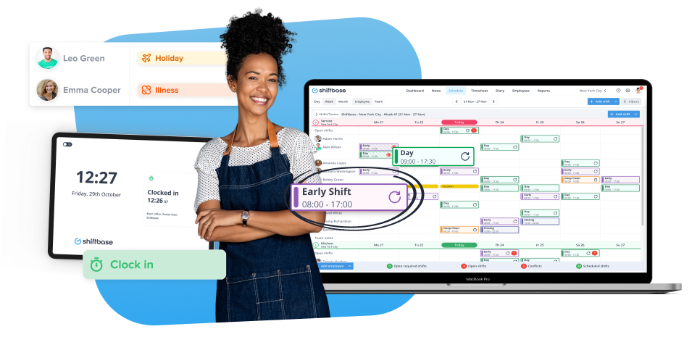

TRY IT NOW FOR FREE

