Employee Handbook Template
[Year]
Revised on [Date]

Contents  Preface  Welcome to the team  Mission and company values  Philosophy - Who are we?  Company  Corporate Culture  Introduction of leadership team  Candidate experience  Our hiring process  Employee experience  Onboarding  Welcome Guide  Performance Evaluations  Employee engagement, communication  and transparency  Our resources  Transparent communication  Internal communication  Workspaces and access credentials  Working style at [Company name]  Office routine and standards  Employer branding  Compensation and development  Value proposition and compensation structures  Training and further education  Employee benefits  Corporate benefits  Working hours  Vacation policies  other absences  Workplace policies  Employee health and safety  Confidentiality and data protection  Remote work and flexible working models  Termination and exit  Resignation by employee  Exit interview for resignation  Exit interview for termination  by the company | Page 1  Page 2  Page 3  Page 3  Page 4  Page 5  Page 6  Page 6  Page 7  Page 8  Page 8  Page 8  Page 9  Page 9  Page 10  Page 11  Page 11  Page 12  Page 12  Page 12  Page 13  Page 14  Page 14  Page 14  Page 15  Page 15  Page 15

Preface

Welcome to the team! We are excited to have you on board and look forward to experiencing an exciting and fulfilling time together.
In this employee handbook, you will find everything you need to quickly and effectively integrate into our team. It contains important policies, our goals, the benefits available to you, and the expectations we have of you. This handbook will be your constant companion to facilitate your start and daily work at [Company Name]. Our goal is to deliver the highest quality in all areas of our activity. As a valuable member of our team, we hope you can identify with our goals and values and strive for a long and successful career with us. We are convinced that your commitment and skills will be crucial in advancing [Company Name] on our path to success. Once again, welcome and we wish you much success and enjoyment in your work at [Company Name]!

Mission and Values
[Inform new employees about what your company does and how you work. Here is an example:]

Mission
Our mission at [Company Name] is to take a leading role in our industry through innovation, commitment, and quality. We strive to provide our customers with exceptional products and services that enrich their lives and positively contribute to society. We are committed to creating sustainable solutions that benefit both our environment and our community.

Company values
Our company values form the foundation of our corporate culture and guide us in our daily actions. They reflect who we are and what we believe in:
[Here you can add appropriate icons or images for illustration.]

Value
Description

Value
Description

Value
Description

Value
Description
These values are not just guidelines for our daily business, but also a commitment to our employees, customers, and society. They are the foundation for our long-term success and the growth of [Company Name].

Philosophy – Who are we?
Company History
[Company Name] was founded in [Year of Establishment] when [Founder's Name(s)] set out with the vision to [brief description of the original idea or goal of the company]. Over the years, [Company Name] evolved from a small [Original Industry] into a leading company in the [Current Industry]. Our journey has been marked by [important milestones, e.g., innovations, expansion, significant partnerships], which have helped us to continuously grow and establish ourselves in the market. Today, we are proud to have [current achievements, e.g., number of employees, international presence, significant products/services] and continue to contribute to [company's goal or vision].

Corporate Culture
Our corporate culture at [Company Name] is characterized by an open and dynamic atmosphere where each individual is valued. We foster a culture of inclusion and diversity, where different perspectives and ideas are welcomed. The promotion of personal and professional development of our employees is important to us. We offer regular training and further education opportunities to support the growth and development of each individual. Our work environment is characterized by transparency, mutual respect, and a strong team orientation. We encourage our employees to communicate openly and share ideas and feedback in order to achieve [company goal or vision] together.

Introduction of the team
[Here, insert a picture of our team to provide a personal insight. A team photo enhances the sense of community and helps new employees to integrate more quickly.]
Employee's name Department Title Possible LinkedIn URL | Employee's name Department Title Possible LinkedIn URL | Employee's name Department Title Possible LinkedIn URL
Employee's name Department Title Possible LinkedIn URL | Employee's name Department Title Possible LinkedIn URL | Employee's name Department Title Possible LinkedIn URL

Candidate Experience
[Describe here the interview process, number of candidates, who conducts the interviews, and whether preliminary tests are required.]
Our hiring process
We are aware of the importance of each recruitment process and take this process very seriously. Every job posting and each candidate contributes to the future and success of our company. Therefore, we would like to give you an insight into our hiring process:
- Application phase: Here you can describe in detail how the application process works, from submitting the documents to the first contact. Selection process: Explain how the selection of applicants is made. This may include a description of the various selection stages, such as preliminary tests, telephone interviews, or assessment centers.
- Interviews: Describe how the job interviews are structured, who participates in them, and what topics and questions are typically addressed.
- Tests and evaluations: If applicable, explain whether and what types of tests (e.g., professional knowledge, personality tests) or assignments are part of the process.
Our hiring process is designed to ensure that we find the best talents while providing each applicant with a positive and informative experience. We look forward to getting to know you and hope you will feel comfortable with us.

Employee Experience
Onboarding
Welcome to the team! We are thrilled to have you on board and look forward to your first day with us. Please arrive at [XX] by [Time]. Your first day at [Company Name] will be both informative and inspiring. We'll start with a warm welcome and introduce you to the rest of the team. Then you'll be given a tour of our premises to give you a comprehensive impression of your new work environment. In an introductory orientation session, you'll learn more about [Company Name] and its core values. We will also clarify any final formalities in our human resources department.

Welcome Guide
To help you get started, please take a look at our welcome guide. Additionally, we have compiled some useful tips and tricks for you:
Asking questions:
Don't hesitate to ask questions, especially when it comes to new processes, projects, or colleagues. This helps you understand expectations and stay up-to-date.
Absorbing information:
In your first week, it's particularly important to absorb all new information. Familiarize yourself with the company culture, working and communication styles, and the goals of your department and the entire company. This will enable you to quickly dive into your actual tasks.
Parking options:
Parking is available on-site or outside the premises at [Street]. You will receive a parking permit for this.

Performance Reviews
[Important information, for example, on 360-degree feedback, employee development, and assessment procedures]
At [Company Name], we rely on regular performance evaluations to recognize excellent work, identify development potential, and discuss career opportunities. Employees can view and complete their evaluations in our online system. New team members will be informed about the timeframe of these assessments, whether monthly or semi-annually. Our goal is to create an environment for continuous development and growth.

Employee engagement, and Effective Communication Channels
Key Resources For the Team
[To simplify access to information for your employees, it is recommended to integrate direct URL links in each relevant section of your employee handbook.]

To best support our team, we offer a variety of resources, including:
FAQ Section: Here, you can find answers to frequently asked questions.
Bug Reporting: A platform to report issues or bugs.
Company Roadmap: Access to our future plans and goals.
Help Center: Support and guides for various topics.

Transparent Communication
Getting accustomed to new tools and software can be a challenge at the beginning of any role. We use a combination of customized and traditional tools such as [Example CRM in the Sales Team] to streamline our daily work. We provide you with the necessary time to familiarize yourself with these tools.

Internal Communication
We place a high emphasis on clear and open communication. Here is an overview of the channels we use for internal communication, such as:
- Slack or Microsoft Teams for quick team communication
- WhatsApp groups for spontaneous exchange
- Intranet
Workspaces and Access Credentials
Each team has specific workspaces and uses different tools. In this section, you will receive information about the company's key workspaces, password storage locations, and how to handle document exchange. With these resources and information, we aim to create an atmosphere of trust and openness and facilitate your integration into our company.

Working Style at [Company Name]
Office Routine and Norms
Our office routine at [Company Name] is characterized by a balance between professionalism and a relaxed atmosphere. We believe that a positive and supportive work environment significantly contributes to our productivity and creativity.
Flexible Working Hours
We offer flexible working hours to support a balanced work-life equilibrium.
Dress Code
Our dress code is [Example Business Casual]. We believe that employees should feel comfortable in their attire as long as it is professional and appropriate.
Breaks
We encourage regular breaks to promote concentration and facilitate interaction among colleagues.
Meetings and Communication
We prioritize efficient meetings with clear agendas and promote open communication, both in face-to-face conversations and through digital platforms.

Employer Branding
Employer Branding is of great importance to [Company Name]. Our goal is not only to be an attractive employer but also a brand known for innovation, employee satisfaction, and social responsibility.
Company Email Address
Clarify to employees the purposes for which the company email address may be used and whether private use is permissible.
Social Media
Clear guidelines for protecting the company's image are essential for those who manage the company's social media channels.
Employee Development
We invest in the training and career development of our employees.
Social Engagement
Our company is involved in social projects and promotes employee participation in charitable activities.
Corporate Culture
We actively communicate our corporate culture and values both internally and externally to convey a consistent and positive image of [Company Name].
Through these measures in the workplace and in employer branding, we aim to establish [Company Name] as a modern, employee-friendly, and socially responsible workplace.

Compensation and Development
Value proposition and Compensation Model
Our value proposition at [Company Name] is based on fairness and transparency. We place great importance on ensuring that our employees receive compensation that matches their role, skills, and performance.
Payment Mode
Our employees receive their salary within a defined pay cycle.
Payment Frequency
Compensation is provided regularly and on time to enable reliable financial planning.
Payment Date
Salaries are typically paid on the [specific weekday or day of the month] of each month.
We are committed to providing a compensation system that is not only fair but also supports the personal and professional development of our employees.

Training and development
Continuous development of our employees is a central part of our company philosophy. We offer regular training and further education to strengthen professional competencies and stay up-to-date with the latest industry trends.

Employee Benefits
Corporate Benefits
At [Company Name], we offer a range of attractive supplementary benefits to promote the well-being and satisfaction of our employees. These include:
Health and Wellness Programs
Offerings such as gym memberships or health courses.
Company Pension Scheme
Support for financial security in retirement.
Employee Discounts
Discounts on products and services both within and outside the company.
Meals
A selection of healthy and delicious meals available for free or at a discounted price.

Working Hours
[Specify the exact working hours.]
Our goal is to provide flexible working hour models that allow for a balanced work-life equilibrium. The exact working hours may vary depending on the department and role, with an emphasis on maintaining a reasonable balance between work and leisure.

Holiday Regulations
At [Company Name], our employees are entitled to [Number] days of vacation per year. The entitlement begins from the day you join the company. Planning and approval of your vacation require coordination with your team and the consent of your supervisor.
To request vacation days, please use our internal software. Once approved by your supervisor, you can take your planned vacation. It is not necessary to provide a reason for your vacation request. Unused vacation days can be carried over to the next year. However, we recommend taking your vacation within the current year. Please note that accrued vacation days from the previous year may expire by [Date] of the following year.

Other Absences
[Provide more information on sick leave, parental leave, etc.]
Sick Leave
In case of illness, it's important to promptly inform your manager and submit a sick leave request. For a smooth process, we recommend using our HR software, which allows you to request leave quickly and easily. Please note that a medical certificate is required for the approval of sick leave.
Parental Leave
The addition of a new family member is a significant life event. To provide parents with adequate time with their newborn, we offer parental leave. This includes [Number] consecutive weeks, of which [Number] weeks must be taken immediately after childbirth. The remaining parental leave can be used flexibly by arrangement. In special cases, maternity leave can be extended.
Special Leave for Relocation
When relocating your residence, employees are entitled to one day of special leave with continued payment of salary. This should be announced in advance to ensure a smooth process. At [Company Name], we understand that life outside of work brings important events, and we support our employees during these phases.

Workplace Policies
Safety and Employee Health
At [Company Name], we prioritize the safety and health of our employees. We implement strict workplace safety standards and provide regular training on safety practices. Additionally, we promote a healthy work environment through ergonomic office equipment and awareness of health-promoting measures.

Confidentiality and Data Privacy
Preserving confidentiality and data privacy are central aspects of our company policy. We are committed to protecting the personal data of our employees and customers and consistently adhere to relevant policies. Regular data privacy training ensures that our employees are informed about all relevant regulations.

Telecommuting and Flexible Work Models
To meet the needs of our employees and promote a balanced work-life balance, [Company Name] offers flexible work models. This includes the option for telecommuting, allowing employees to work from home or another location. We ensure that a productive and secure work environment is maintained even in remote work settings.

Resignation and Termination
Resignation by the Employee
In the case of voluntary departure, we request our employees to inform us of their decision through a resignation notice with an appropriate notice period. We respect their decision and support them in their further career journey.

Exit interview Upon Resignation
Upon resignation, we conduct an exit interview. The aim of this conversation is to gather constructive feedback about the work experience at [Company Name]. This information helps us continuously improve our work environment and conditions.

Exit Interview in Case of Termination by the Company
If the employment relationship is terminated from our side, we also conduct an exit interview. This provides us with the opportunity to make the process transparent and fair and gain valuable insights for both parties.
In all cases, we emphasize that the departure process is conducted respectfully and professionally to ensure a positive and professional final experience with [Company Name].

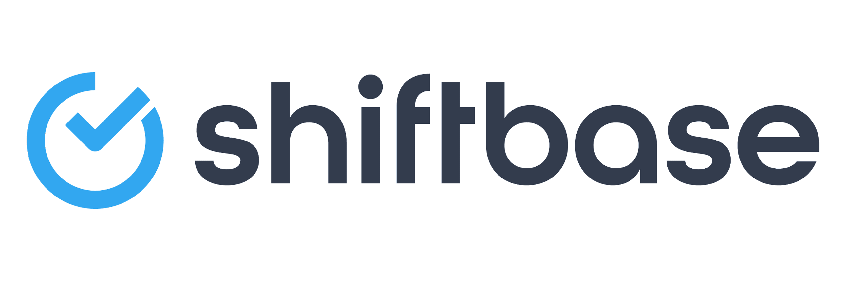
TRY SHIFTBASE FOR FREE AND WITHOUT OBLIGATION FOR 14 DAYS
Discover the comprehensive HR features of Shiftbase and see how you can manage all your employee data in one place. With Shiftbase, you can create detailed analyses of your business performance, gaining valuable insights into your company. Benefit from customizable reports and dashboards that provide you with a real-time overview of your entire company. Experience for yourself how Shiftbase simplifies your HR processes and optimizes your company management.

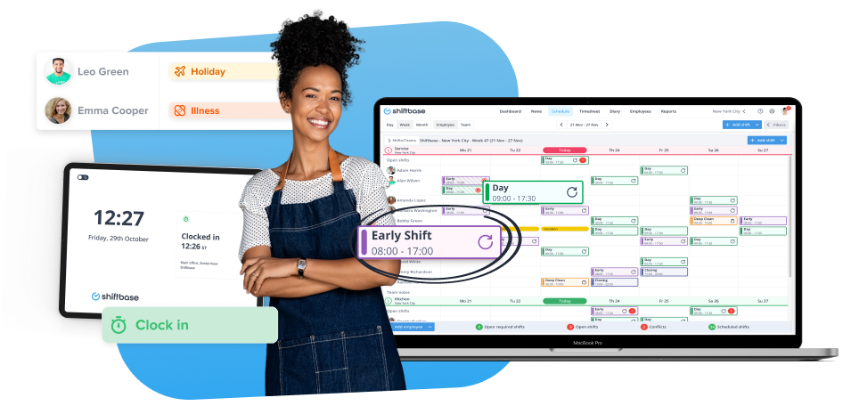

TRY IT NOW FOR FREE

