Shiftbase Template  
Clock in and out Policy



# 

# 

# About this template

This Clocking in and Out Policy Template is designed to help employers clearly define expectations around time tracking, attendance, and payroll accuracy. It covers key elements such as procedures for clocking in/out, handling breaks, managing overtime, and addressing violations. The goal is to promote fairness, prevent time theft, and ensure compliance with labour laws.

How to use:

1. **Customise the placeholders:** Replace brackets like [Insert Date], [X years], and [Your Country/Region] with your company's specific details.
2. **Tailor sections to your setup:**

* Choose the relevant time-tracking method (e.g. biometric, mobile app, physical time clock).
* Adapt break and overtime rules based on your legal obligations and company policy.
* Adjust disciplinary actions to reflect your organisation’s approach.

1. **Involve your HR or legal team:**  
   Before rolling it out, review the policy with your HR or legal advisor to ensure compliance with local labour laws and internal standards.
2. **Communicate with employees:** Make sure every employee receives this policy—ideally as part of the employee handbook—and understands how it affects their daily work routine.
3. **Keep it up to date:** Review the policy regularly, especially after changes in legislation, technology, or company processes.

# Clock in an out Policy

## **Effective Date**

[Insert Date]

## **Applies To**

All employees, including hourly, salaried, full-time, part-time, and remote staff

## **1. Purpose**

The purpose of this policy is to establish clear time clock rules for recording employee hours worked. It ensures accurate payroll, compliance with labour laws, and consistency across all departments. The policy applies regardless of the employee's role or work location.

## **2. Definitions**

- **Clocking in/out:** The act of recording the beginning and end of a work shift.  
- **Time clock system:** The method used to track time (e.g. mobile app, biometric scanner, web-based portal, or physical time clock).  
- **Work hours:** Any time during which an employee is scheduled and required to perform job-related duties.  
- **Overtime hours:** Hours worked beyond standard full-time hours, requiring additional compensation.  
- **Pay period:** The recurring schedule (e.g., weekly, bi-weekly) that determines when employees are paid properly.

## **3. Scope**

This policy applies to all staff members, including:  
- Hourly employees  
- Salaried employees (where time tracking is necessary)  
- Remote and off-site employees  
- Contractors (if contractually obligated)

## 

## 

## 

## 

## 

## 

## **4. Clocking Procedures**

## **4.1 Daily Clock-In**

- All employees must clock in at the start of their shift using the designated time clock system.  
- Clocking in early is only allowed if work begins early (pre-approval required).  
- Employees must not perform any work before clocking in.

## **4.2 Daily Clock-Out**

- Employees must clock out immediately after finishing work.  
- If you continue working past your scheduled end time, you must notify your manager and request overtime approval.

## **4.3 Breaks**

- Meal breaks (30+ mins): Employees must clock out and clock in upon return.  
- Short breaks (under 20 mins): These are paid and do not require a time clock punch, unless company-specific exceptions apply.

## **4.4 Remote and Field Work**

- Remote employees must use the mobile time tracking app with GPS functionality.  
- GPS logs will verify clock-in locations. Clocking from unauthorised locations may be subject to disciplinary action.

## **5. Time Rounding Policy**

- Time entries may be rounded to the nearest quarter hour.  
- Rounding will be applied fairly and consistently.  
- Rounding must not result in employees being underpaid or missing hours worked.

## **6. Missed or Incorrect Punches**

- Employees who forget to clock in or out must notify their supervisor within the same workday.  
- Manual adjustments require approval and an audit trail.  
- Excessive missed punches will be investigated and may result in disciplinary action.

## **7. Prohibited Actions**

The following actions are strictly prohibited:  
- “Buddy punching” (clocking in for another employee)  
- Falsifying employee timesheets  
- Recording more hours than worked  
- Leaving early without clocking out  
- Clocking in before arriving on site

## **8. Overtime Approval**

- Overtime hours must be pre-approved by a supervisor.  
- Unauthorised overtime may not be compensated and could result in action.  
- All hours worked, including overtime, must be accurately recorded.

## **9. Review and Audit**

- Management may conduct regular audits of employee time records.  
- Discrepancies will be addressed and, if needed, corrected through the payroll department.  
- Employees are encouraged to report suspected time theft or errors immediately.

## **10. Record Keeping**

- Accurate records of employee hours, breaks, and overtime will be retained for at least [X years] as per [Your Country/Region] labour law.  
- All time tracking data will be securely stored in the company’s time clock system.

## **11. Communication & Training**

- This policy is included in the employee handbook.  
- New hires will receive training on the clock in/clock out process.  
- Refresher sessions may be scheduled when systems are updated, or time clock rules change.

## **12. Policy Acknowledgement**

Employees are required to sign an acknowledgment form confirming they’ve read and understood this clocking in and out policy. Lack of compliance does not excuse policy violations.

## **Need Help or Have Questions?**

Please contact your line manager or HR for clarification. Feedback is welcome and helps us improve our system and support a fair workplace.

# Try Shiftbase 14 days for free

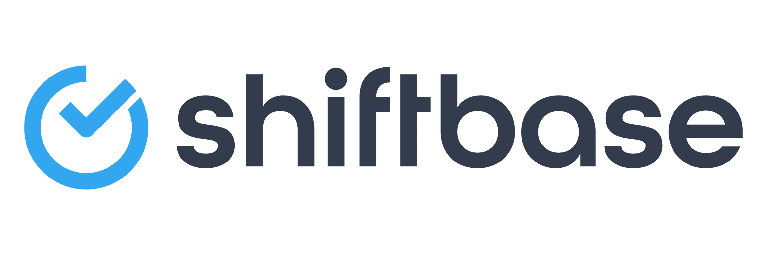

**TRY SHIFTBASE FOR FREE AND WITHOUT OBLIGATION FOR 14 DAYS**

Discover the comprehensive HR features of Shiftbase and see how you can manage all your employee data in one place. With Shiftbase, you can create detailed analyses of your business performance, gaining valuable insights into your company. Benefit from customizable reports and dashboards that provide you with a real-time overview of your entire company. Experience for yourself how Shiftbase simplifies your HR processes and optimizes your company management.

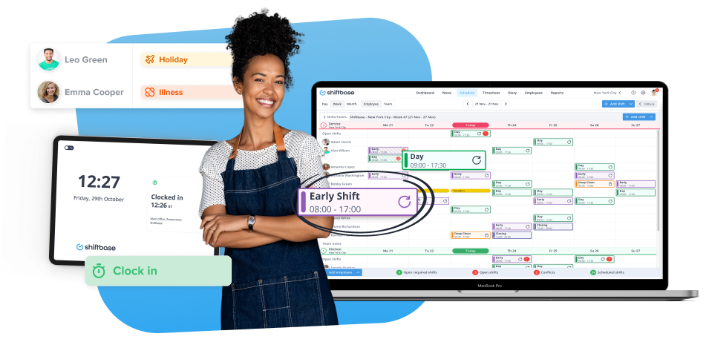

[TRY IT NOW FOR FREE](https://app.shiftbase.com/signup?plan=premium&language=en&signup_cta_source=hero-main&signup_cta_url=https:%2F%2Fwww.shiftbase.com)