Shiftbase template
Job Rejections Email Templates

About this template
One of the most challenging tasks in human resources is communicating rejections in the application process in a respectful and professional manner. The correct procedure when rejecting applications is crucial to maintaining the reputation of your company and keeping candidates in good memory.
Here we will cover various aspects of application rejections, including rejections on applications in general and rejections after an interview. We will also provide sample rejection letters to help you create your own rejection letters.
A well-thought-out and professionally worded rejection can not only show respect to the applicants, but also help your company to be perceived as an employer of choice. It is important to find the right words to support candidates in their professional career, even if they were not selected for the advertised position.
We understand that designing rejection letters can be a challenging task, so we provide you with templates and examples that can serve as inspiration. We firmly believe that fair and respectful communication in the application process is beneficial for everyone involved, and we hope these templates will help you improve your rejections and build positive relationships with applicants.

Rejection of application sample #1
Dear Ms./Mr. [last name],
Thank you for your interest in the [job title] position and the time you invested in the application process. After carefully examining all applicants, we unfortunately have to inform you that we have chosen another applicant. We were impressed with your qualifications, but another candidate was a better fit for the specific requirements of the position.
We wish you all the best for your professional future and thank you again for your interest in our company.
Best regards,
[your name]

Rejection of application sample #2
Dear Ms/Mr [last name],
We would like to thank you very much for applying for the position [job title]. Despite your impressive experience and skills, we have decided to fill the position with another candidate whose profile is even closer to our current needs.
We regret that we cannot give you more positive feedback and wish you much success in your future career.
Best regards,
[your name]

Rejection after an interview pattern #1
Dear Ms./Mr. [last name],
We would like to thank you very much for your interest in the position [job title] and your participation in the interview at [your company]. It was enriching to get to know you better and learn more about your impressive professional qualifications.
Your commitment and your skills have left an extremely positive impression on us. Nevertheless, we would like to inform you today that the decision has been made to give the position to another person who fits the job profile even better.
We realize this is not easy news and we appreciate your application and interest in [your company]. We are confident that you will continue to be successful in your professional career and wish you much success in your next professional opportunity.
Thank you again for your understanding and we hope you remember us fondly.
With best regards and best wishes for your future,
[your name]

Rejection after an interview #2
Dear Ms./Mr. [last name],
I would like to thank you very much for your interest in the position [job title] and your participation in the interview at [your company]. It was a pleasure getting to know you personally and learning more about your qualifications and experiences.
After a thorough examination of all applicants and careful consideration of the candidates, we decided on another applicant who better meets our current requirements. This decision was not easy for us because we value your qualifications and potential.
We would like to thank you again for your interest in our company and the position. We wish you much success in your professional future and hope that you will soon find a suitable opportunity where you can fully utilize your skills.
Thank you again and we hope you remember us fondly. We value your time and interest in [your company].
If you have any questions or would like to discuss further, I would be happy to help you.

Best regards,
[your name]

Try Shiftbase free for 14 days.
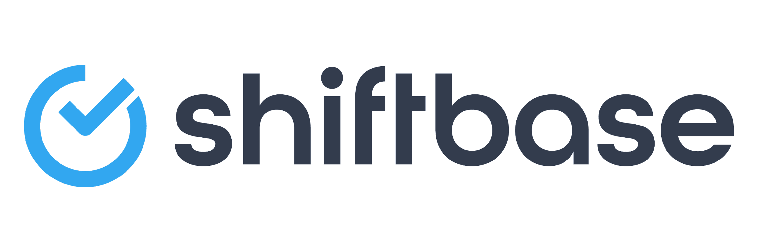
TRY SHIFTBASE FOR FREE AND WITHOUT OBLIGATION FOR 14 DAYS
Discover the comprehensive HR features of Shiftbase and see how you can manage all your employee data in one place. With Shiftbase, you can create detailed analyses of your business performance, gaining valuable insights into your company. Benefit from customizable reports and dashboards that provide you with a real-time overview of your entire company. Experience for yourself how Shiftbase simplifies your HR processes and optimizes your company management.
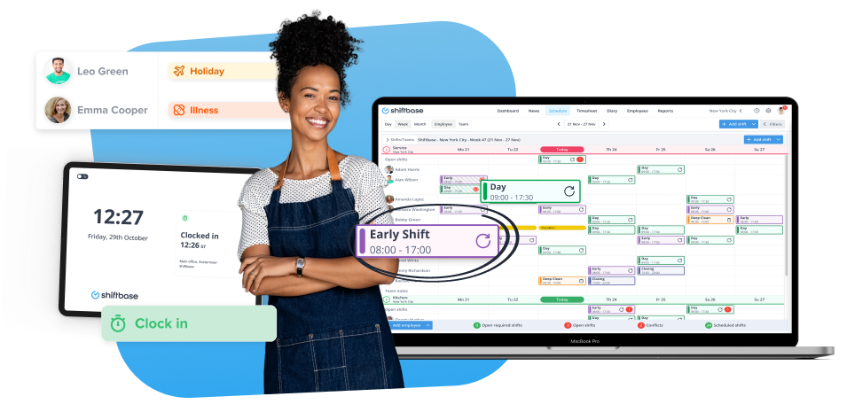

TRY IT NOW FOR FREE

